**WEB SHOP**



1. **High Level Design**
2. **Low Level Design**
3. **UML**
4. **Technologies can be used**
5. **Add-on features**
6. **High Level Design (HLD)**

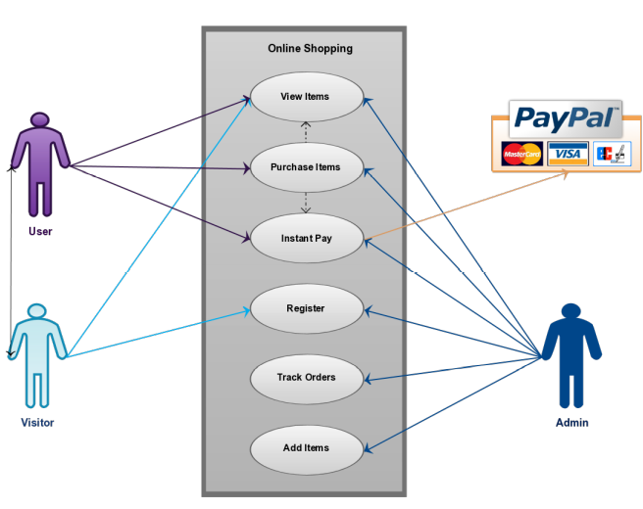

**LLD (Low Level Design)** 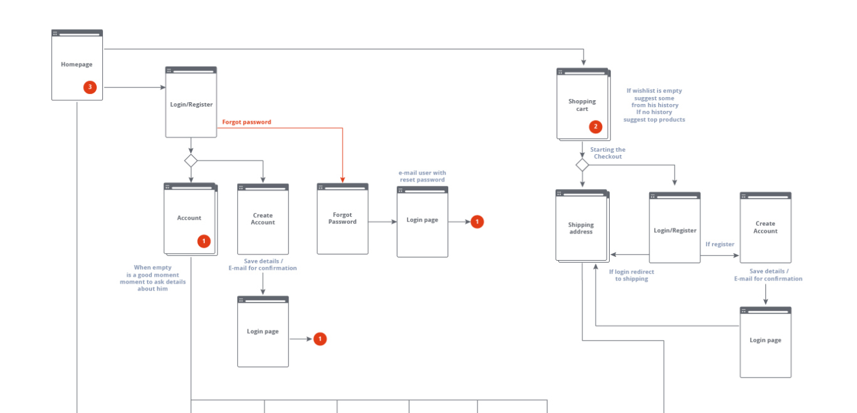 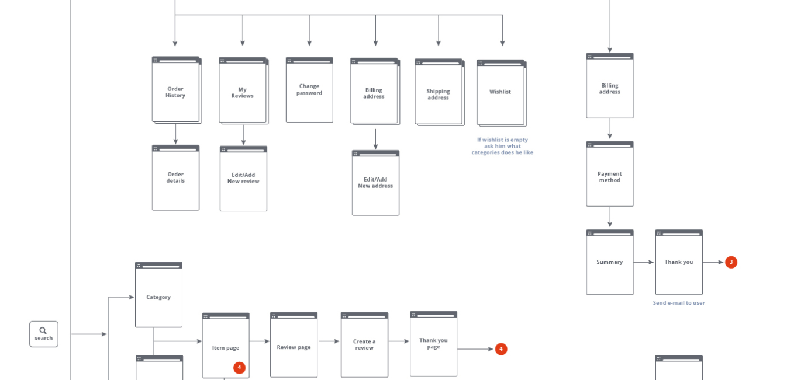 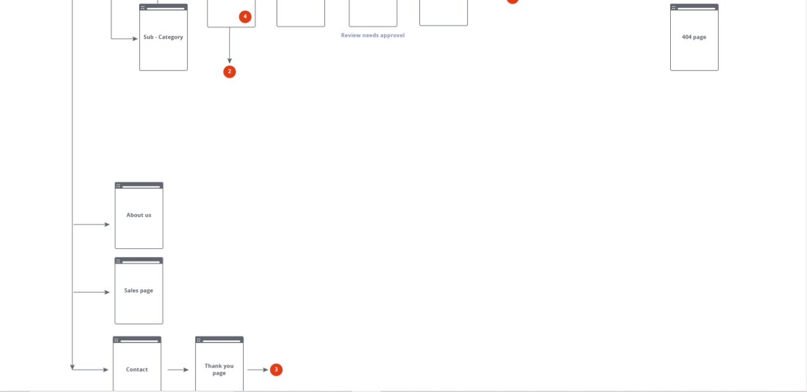

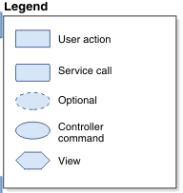

# Overall shopping flow diagram

A diagram showing various scenarios including the service calls, optional commands,

controller commands and views. The UML can be made in Visio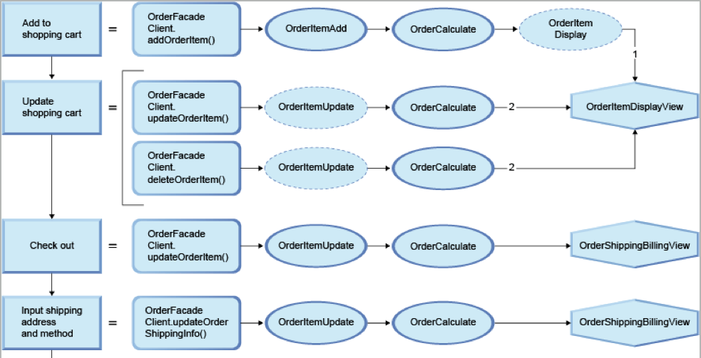 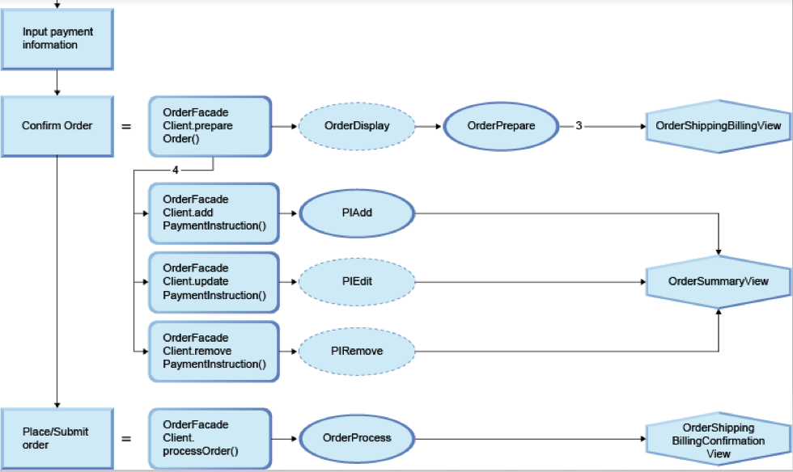

**Technologies used**

* [**Content management system**](https://elogic.co/glossary/content-management-system/)**(CMS)** – There are different options from a simple WordPress CMS system, to a more complex like Magento, which is a popular [ecommerce platform](https://elogic.co/glossary/ecommerce-platform/) and CMS. Other examples of CMS software include Drupal, and Joomla. The main difference between these CMS is in customization, functionality, and design. Magento is a perfect fit for large online stores. There is also an option to use WordPress blog CMS with the Magento [ecommerce platform](https://elogic.co/glossary/ecommerce-platform/).
* **Web framework** – jQuery, reactjs angular JS, bootstrap are well-known front-end framework for building responsive websites.
* **Web server** – Apache HTTP server, Nginx are popular web servers that can also be used as a reverse proxy, load balancer, mail proxy, and HTTP cache.
* **Programming language** – Platforms like Magento 2.3.x support PHP 7.1.3+. Depending on the ecommerce platform, this may vary.
* **Hosting/Scaling** – Amazon Web Services (AWS) and Azure are the leading cloud platforms. AWS and Azure both makes it easy to set up and manage cloud-hosted databases.
* **Web application accelerator** –Magento, Varnish Cache is a good choice for web accelerator and HTTP caching reverse proxy.
* **Data structure store** – Redis is an open-source, in-memory data structure store that is used as a database, cache, and message broker.
* **Tag Managers** – Google Tag Manager manages JavaScript and HTML tags used for tracking and using analytics on websites. It supports third-party analytics and offers advanced tag management.
* **Mobile frameworks** – jQuery Mobile is a touch-optimized web framework used to build websites and apps for smart devices.
* **DNS hosting** – Domain and hosting selection.

**Add-on Features (Can be added to e-commerce site)**

* A customizable menu according to customer preference.
* A product wishlist
* A product [inventory](https://elogic.co/glossary/inventory/) management system
* CRM integration
* A blog module
* Multicurrency/Multilanguage
* Enhanced search ( Elastic search)
* One-step checkout
* The ability to log in with [social media](https://elogic.co/glossary/social-media/)/email accounts
* Integrations with review sites
* Integrations with payment processors/gateways

**THANK YOU**